**4.1 Sociodemographic factors of the participants**

**Table 4.1. Sociodemographic factors**

| **Characteristic** | **N = 200** |
| --- | --- |
| Age |  |
| >56 years | 1 (0.5%) |
| 15-25 years | 29 (15%) |
| 36-45 years | 142 (71%) |
| 46-55 years | 28 (14%) |
| Gender |  |
| Female | 86 (43%) |
| Male | 114 (57%) |
| Marital Status |  |
| Divorced | 1 (0.5%) |
| Married | 104 (52%) |
| Single | 94 (47%) |
| Widowed | 1 (0.5%) |
| Level of Education |  |
| No formal education | 2 (1.0%) |
| Primary | 2 (1.0%) |
| Secondary | 101 (51%) |
| Tertiary | 95 (48%) |
| Occupation |  |
| Government employee | 25 (13%) |
| Self-employed | 76 (38%) |
| Unemployed | 99 (50%) |
| Monthly Income |  |
| #100000 - #150000 | 101 (51%) |
| #20000 - #50000 | 2 (1.0%) |
| #51000 - #100000 | 39 (20%) |
| > # 200000 | 58 (29%) |
| Duration o fDiabetes Diagnosis |  |
| < 1 year | 17 (8.5%) |
| >10 years | 16 (8.0%) |
| 1-5 years | 137 (69%) |
| 6-10 years | 30 (15%) |
| Presence of Complications |  |
| Not sure | 36 (18%) |
| No | 146 (73%) |
| Yes | 18 (9.0%) |

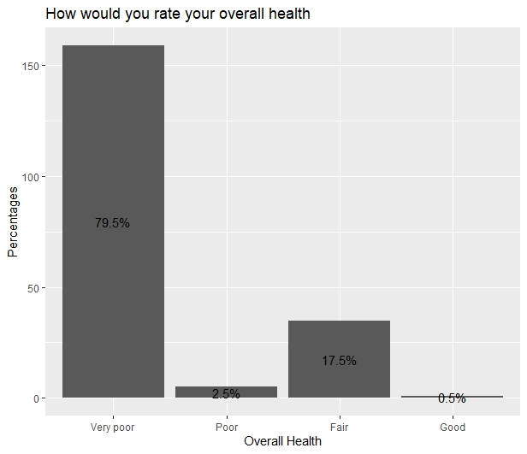

WHOBREF

| variable | n | min | max | median | iqr | mean | sd |
| --- | --- | --- | --- | --- | --- | --- | --- |
| DOM1 | 200 | 10 | 65.000 | 30.000 | 10.000 | 29.650 | 9.622 |
| DOM2 | 200 | 10 | 65.000 | 35.000 | 15.000 | 41.550 | 12.575 |
| DOM3 | 200 | 25 | 58.333 | 41.667 | 8.333 | 38.708 | 7.467 |
| DOM4 | 200 | 5 | 65.000 | 35.000 | 10.000 | 36.250 | 7.242 |

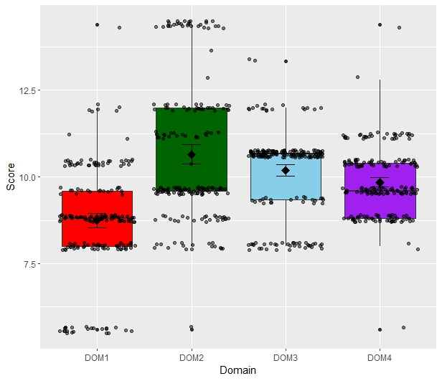

| Variables | Physical Health | | Pyschological | | Social Relationship | | Environment | |
| --- | --- | --- | --- | --- | --- | --- | --- | --- |
|  | Mean | SD | Mean | SD | Mean | SD | Mean | SD |
| Age Group |  |  |  |  |  |  |  |  |
| 15-25 years | 34.65 | 5.33 | 39.31 | 9.23 | 37.06 | 4.76 | 36.20 | 5.77 |
| 36-45 years | 28.94 | 9.87 | 41.44 | 13.88 | 38.73 | 8.43 | 35.14 | 7.50 |
| 46-55 years | 28.03 | 10.57 | 44.10 | 7.46 | 40.17 | 3.25 | 41.60 | 4.31 |
| >56 years | 30.00 | - | 50.00 | - | 41.66 | - | 45.00 | - |
| P-value |  |  |  |  |  |  |  |  |
| Gender |  |  |  |  |  |  |  |  |
| Female | 30.69 | 9.55 | 42.90 | 12.04 | 38.95 | 8.80 | 34.82 | 9.08 |
| Male | 28.85 | 9.64 | 40.52 | 12.92 | 38.52 | 6.31 | 37.32 | 5.24 |
| P-value |  |  |  |  |  |  |  |  |
| Level of Education |  |  |  |  |  |  |  |  |
| No formal education | 25.00 | 0.00 | 45.00 | 0.00 | 33.33 | 0.00 | 5.00 | 0.00 |
| Primary | 37.50 | 10.60 | 50.00 | 0.00 | 41.66 | 0.00 | 40.00 | 7.07 |
| Secondary | 31.98 | 9.11 | 41.03 | 11.32 | 38.36 | 8.08 | 36.53 | 5.41 |
| Tertiary | 27.10 | 9.60 | 41.84 | 14.01 | 39.12 | 6.88 | 36.73 | 6.51 |
| P-value |  |  |  |  |  |  |  |  |
| Monthly Income |  |  |  |  |  |  |  |  |
| #100000 - #150000 | 26.18 | 8.37 | 39.80 | 13.47 | 39.19 | 6.40 | 36.13 | 5.60 |
| #20000 - #50000 | 25.00 | 0.00 | 45.00 | 0.00 | 33.33 | 0.00 | 5.00 | 0.00 |
| #51000 - #100000 | 35.12 | 12.11 | 35.25 | 5.95 | 41.66 | 8.76 | 36.41 | 5.61 |
| > # 200000 | 32.15 | 7.32 | 48.70 | 11.18 | 36.06 | 7.54 | 37.75 | 6.69 |
|  |  |  |  |  |  |  |  |  |
|  |  |  |  |  |  |  |  |  |
|  |  |  |  |  |  |  |  |  |

Table 4.3. The effect of selected socio-demographical factors on the quality of life of the participants

| Variables | Physical Health | | Pyschological | | Social Relationship | | Environment | |
| --- | --- | --- | --- | --- | --- | --- | --- | --- |
|  | Mean | SD | Mean | SD | Mean | SD | Mean | SD |
| Age Group |  |  |  |  |  |  |  |  |
| 15-25 years | 34.65 | 5.33 | 39.31 | 9.23 | 37.06 | 4.76 | 36.20 | 5.77 |
| 36-45 years | 28.94 | 9.87 | 41.44 | 13.88 | 38.73 | 8.43 | 35.14 | 7.50 |
| 46-55 years | 28.03 | 10.57 | 44.10 | 7.46 | 40.17 | 3.25 | 41.60 | 4.31 |
| >56 years | 30.00 | - | 50.00 | - | 41.66 | - | 45.00 | - |
| P-value | 0.023* |  | 0.471 |  | 0.453 |  | 0.000* |  |
| Gender |  |  |  |  |  |  |  |  |
| Female | 30.69 | 9.55 | 42.90 | 12.04 | 38.95 | 8.80 | 34.82 | 9.08 |
| Male | 28.85 | 9.64 | 40.52 | 12.92 | 38.52 | 6.31 | 37.32 | 5.24 |
| P-value | 0.182 |  | 0.186 |  | 0.688 |  | 0.015* |  |
| Level of Education |  |  |  |  |  |  |  |  |
| No formal education | 25.00 | 0.00 | 45.00 | 0.00 | 33.33 | 0.00 | 5.00 | 0.00 |
| Primary | 37.50 | 10.60 | 50.00 | 0.00 | 41.66 | 0.00 | 40.00 | 7.07 |
| Secondary | 31.98 | 9.11 | 41.03 | 11.32 | 38.36 | 8.08 | 36.53 | 5.41 |
| Tertiary | 27.10 | 9.60 | 41.84 | 14.01 | 39.12 | 6.88 | 36.73 | 6.51 |
| P-value | 0.002* |  | 0.739 |  | 0.606 |  | 0.000* |  |
| Monthly Income |  |  |  |  |  |  |  |  |
| #100000 - #150000 | 26.18 | 8.37 | 39.80 | 13.47 | 39.19 | 6.40 | 36.13 | 5.60 |
| #20000 - #50000 | 25.00 | 0.00 | 45.00 | 0.00 | 33.33 | 0.00 | 5.00 | 0.00 |
| #51000 - #100000 | 35.12 | 12.11 | 35.25 | 5.95 | 41.66 | 8.76 | 36.41 | 5.61 |
| > # 200000 | 32.15 | 7.32 | 48.70 | 11.18 | 36.06 | 7.54 | 37.75 | 6.69 |
| P-value | 0.000* |  | 0.000* |  | 0.002* |  | 0.000* |  |

*-significant at p-value <0.05